The Fringe – Investor’s Prospectus (Details)
This document contains more details about who we are, what we are doing, and the industry research that drives our decisions (see http://www.mmogchart.com). It is meant to be read AFTER and provide additional details to the points in the brief investor’s prospectus. Please contact me at rick@fringe-online.com if you do not have that document, have any questions, or would like to check out an exclusive VIP demo of the game. You can also see the latest in the on-going development effort at http://fringe-online.com.

Who We Are

Gremlin Games, Inc.
Gremlin Games is a (soon to be) incorporated game development company committed to developing subscription based multi-player internet games. The Fringe is the first of these ventures. Each game produced will be represented by its own LLC. Gremlin Games will provide all production facilities and labor for the game. As an investor for The Fringe, you will own a percentage of this game company, and you will be able to earn returns on this game as long as it exists. We value our investors, so when we work on future games, our current investors will be the first people we offer investment opportunities to. The principal officers of Gremlin Games are Rick Pingry, Justin Neese, and James Killian.

Rick Pingry – CEO, Technical Director
Rick Pingry brings technical savvy and experience to the team. He started his career in 1992 working as a production coordinator for Morpheus Interactive, a Utah based company that created next generation console games. He continued his education by receiving a Bachelor of Science degree in Computer Science with Honors from Roanoke College. While attending school, Rick owned and operated Digital Allusions, a small 3D animation studio. After graduation in 1998, Rick consulted and worked as an engineer for NewTek, writing video production software, including the Emmy Award Winning Video Toaster. Until recently, he was employed with Northrop Grumman as a software engineer working on 3D visualization and other laser related safety tools for the Air Force Research Labs. As such, He has had the opportunity to publish articles for scientific journals as well as manage software projects on several levels. He is now focused full time making this happen!

For The Fringe and Gremlin Games, Rick will be acting as CEO, reporting to the Board of Directors. He will also be managing the technical aspects of the project and will be implementing a large part of the code base. As technical lead on the project, he and James will advise Justin on the impact of his design decisions.

Justin Neese – Game Director, Artistic Lead
Justin met up with Rick in 1997 as an animator for Digital Allusions. He came on board with a great deal of traditional art experience and an exciting style and passion for the work. He took to 3D animation very quickly and continued his career in that direction working as lead animator for Digital Jag, a local digital post-production company. As a production artist, Justin continually far exceeds the expectations of every client. He is able to quickly adapt to changing workloads, and can bridge the gap between the artistic and the technical.

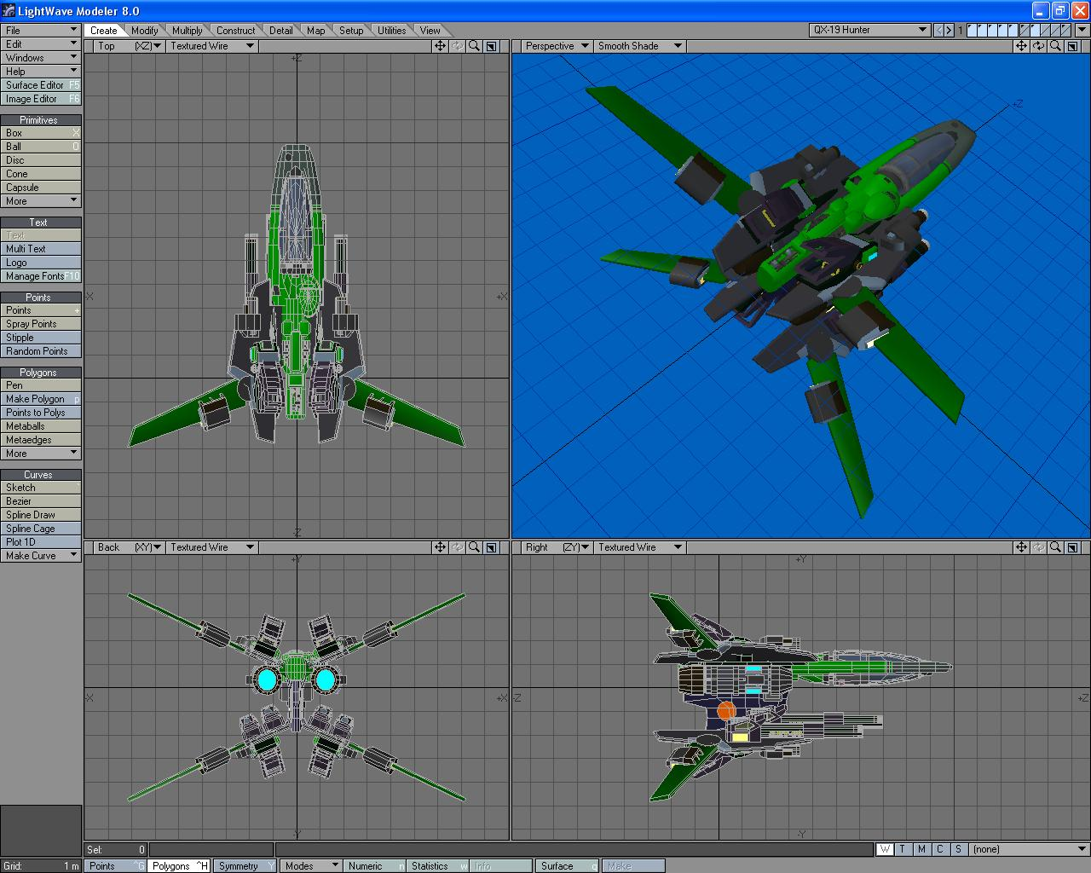
Justin is the real creative genius behind The Fringe, and will take on the dual role of Game Director for the project as a whole, as well as Art Director, managing a team of artists. Justin will also act as Marketing Director in the early stages of the company, and drive the efforts of in-house web site development. He is responsible for all artistic decisions (and much of the implementation) as well as game-play design decisions. Justin will also be responsible for all marketing decisions and will be the principal officer related to every aspect of communication with beta-testers and the player community.

James Killian – Senior Programmer, Development Lead
James met up with Rick at NewTek in 2000, and continues to be a Senior Developer there to this day. As soon as they met, Rick and James teamed up for several years to provide key elements to the Video Editing environment of the Toaster. James has continued to take the lead on some critical systems for NewTek involving some impressive C++ coding. He takes great pride in pushing the limits of the programming language, while focusing on design elements that contributes to very effective, maintainable code. James graduated from the University of Phoenix with a Bachelor’s Degree in Information Technology.

James brings much more to the table than technological prowess. He has an artistic side as well. James started playing the Piano at the age of 9 and continues to play a variety of instruments today. This well-roundedness makes James a key player in all aspects of the game production process. For The Fringe and Gremlin Games, James will play a lead development role and take charge of complete charge of key elements. He has already taken hold of the Physics and Flight Engines for the Game.

What We Are Doing

Subscription Based Multi-Player Online Games
The traditional model for video games is that the consumer purchases a shrink-wrapped package from a vendor, like Wal-Mart. He pays $50 or so one time, takes the game home and plays it by himself until he is sick of it. Most modern games have a multi-player component, so he may be able to play against friends online.

In a subscription based multi-player online game (MMOG), the player may purchase or download the program (called the client). There may or may not be an initial purchase price. To play the game, he has to be connected to the internet, typically with a high-speed connection. While playing, there is a vast community of other players to interact with all over the world. This type of game is becoming very popular because of a community relationship in a fantasy virtual world. Rather than paying money up-front, players pay a monthly subscription or membership fee, usually from $5 - $16 per month. Members gladly pay month after month, not just because the game is exciting, but because of the close relationships they build online.
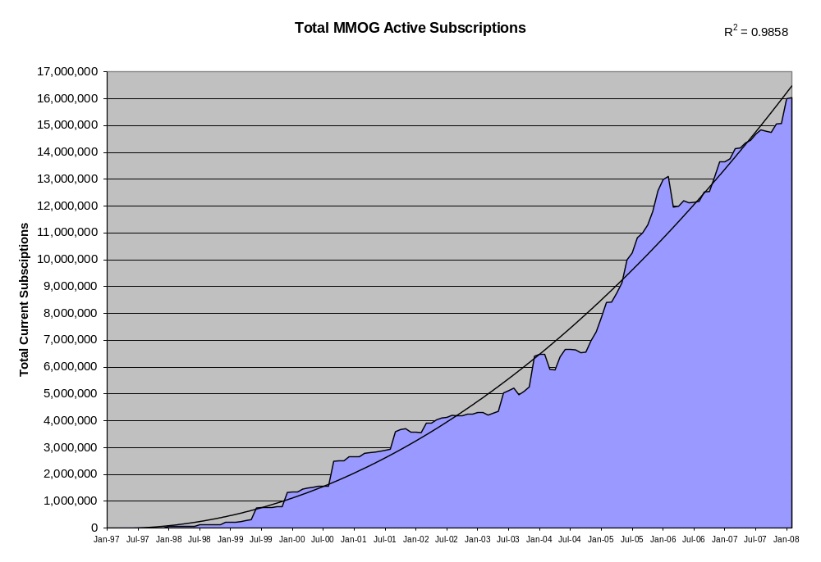
This chart depicts the total number of active subscriptions for all MMOG’s. What we can see from this data is that MMOG’s are currently enjoying an exponential growth rate.

In this way, MMOG’s follow the business model of a service, rather than a product that is created, distributed, and forgotten. Customer Service is of premium importance, and members benefit from regular upgrades to game play and content. While a player may tire of a traditional game in just a very few weeks, players remain committed to a MMOG for many months and even years. While the revenue stream for a traditional game spikes and then declines as new games come out, the revenue for a MMOG continues to climb and climb as it builds its user base and the development company provides for richer online experiences.

Another obvious benefit of this business model over traditional gaming is that distribution costs are almost completely eliminated. There is no need to pay for shrink-wrapped packaging, pay for shelf location, or give up valuable profit margin to every middle man on the distribution channel. All that is required for us to distribute to our customers ourselves is a web server. Using the internet also greatly simplifies providing patches and upgrades.

Using the vast power of internet technology, we can enjoy an incredible economy of scale. While the first iteration of The Fringe will be in English, we will quickly translate all textual aspects of game-play into many languages, particularly in the Asian Markets, which make up more than 50% of the total world-wide market.
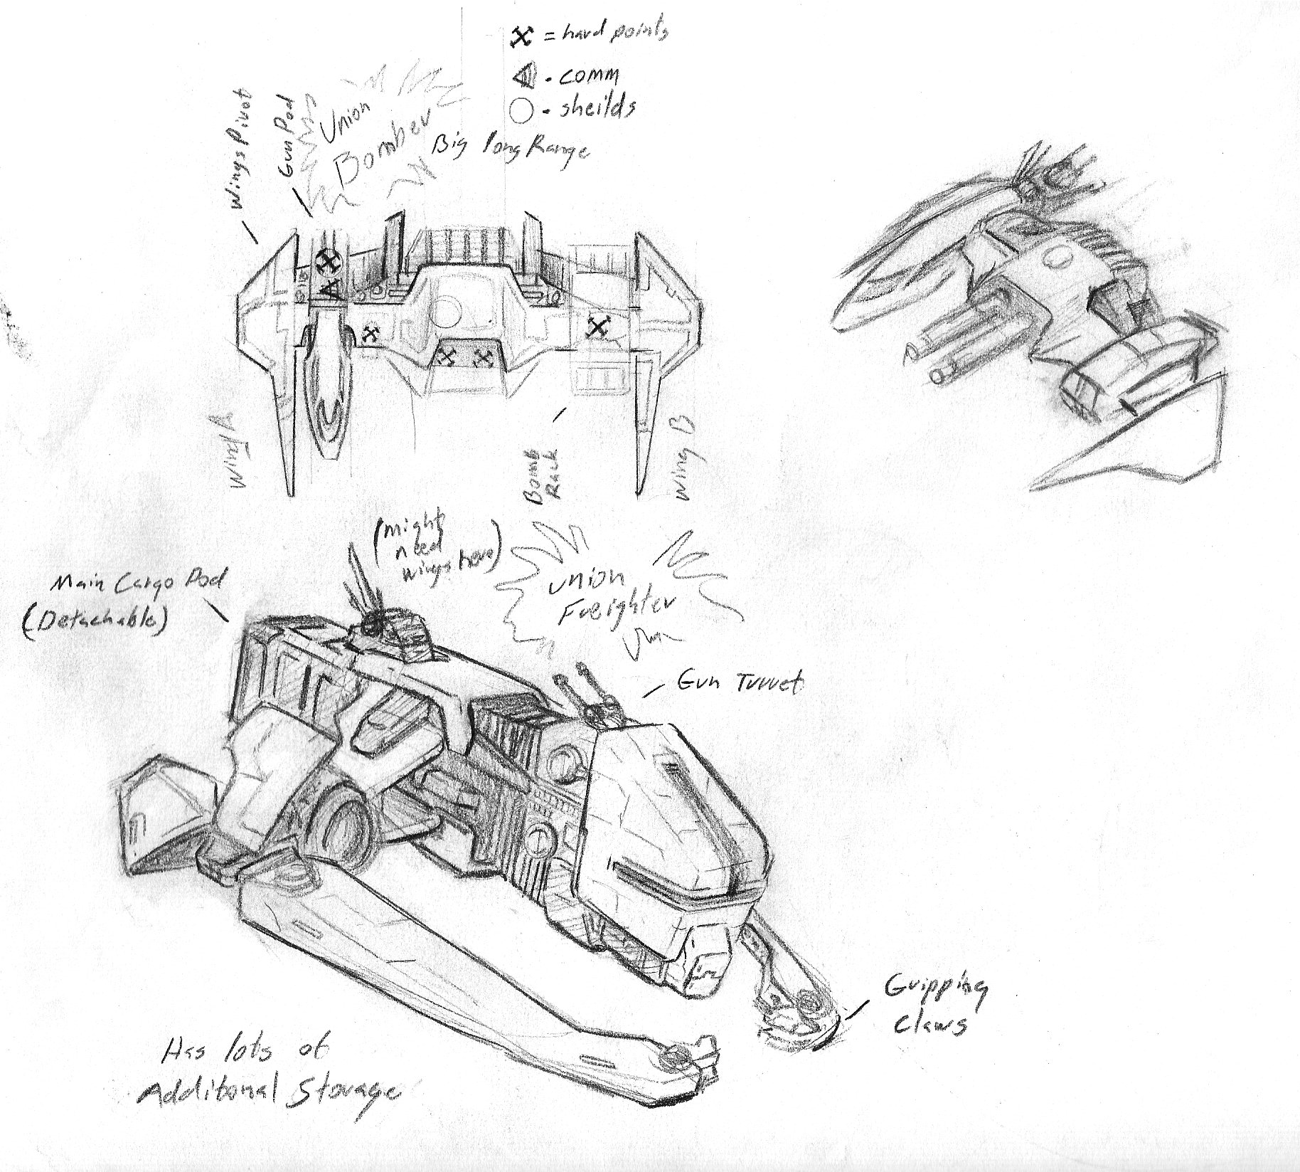

In deciding on a genre for our first game, we studied how the market share was broken up into the different genres:
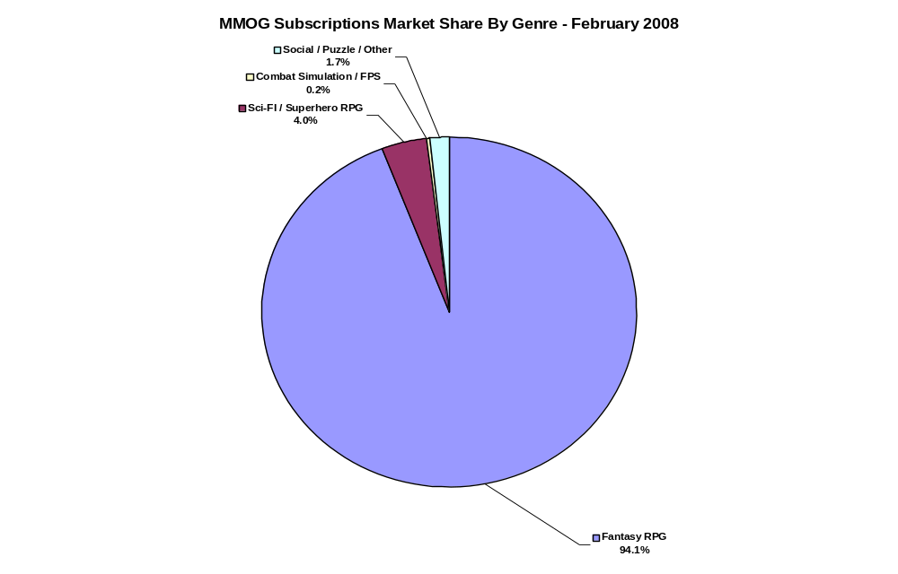
As you can see, Fantasy RPG’s (Role Playing Game) make up the lion’s share of the market. These kinds of games focus on a “Sword and Sorcery” motif reminiscent of Dungeons and Dragons kinds of games. Players range all over the virtual world to fight monsters and collect treasure. These games typically have a great deal of art content that needs to be created.

Fantasy Games also have the greatest competition. The King of the MMOG Universe is the mighty World of Warcraft (WoW), which currently enjoys a membership of 10 Million subscribers, and accounts for 2/3 of the entire market, and an even larger share of the Fantasy RPG market.

Where does the market go from here? Well, it’s still increasing on a steady curve, although some years the market seems to get ahead of itself and in others it falls behind. One interesting issue is the current market share by genre. As of February 2008, 94.1% of the MMOG of the market falls into the category of fantasy RPG; 4.0% in sci-fi RPG (including superheroes), 0.2% in combat simulation / FPS, and 1.7% in the social / other category. To me these numbers indicate a hugely disproportionate emphasis on the fantasy setting – and remember, this does not include many of the predominately fantasy MMOGs in the Asian markets. Even though some MMOGs in the FPS or social / other categories have a sci-fi setting, this nevertheless makes for quite a lopsided market. Consider movies or television, where science fiction is featured far more often than high fantasy, with a correspondingly higher financial success (Lord of the Rings being a notable exception). Several companies are seeking to exploit this untapped potential, while other new entrants continue to focus on the fantasy genre.

While we certainly want to eventually get a piece of this pie, for our first title, we decided to NOT do Fantasy RPG for three reasons:
- There is a HUGE amount of competition
- Fantasy Games require MUCH more content, support, and development time
- As observed, there seems to be a niche to be filled in the Sci-Fi genre, particularly one involving space ships and combat action

For these reasons, we will focus on the Sci-Fi genre, with an overall market of 640,000 and growing. One game in that genre in particular caught our attention because its development company so closely matches our own circumstances. We can benefit from their experience and use them as a model to follow and predict growth.

Eve Online, Competition and Model
Eve Online (http://eve-online.com/ ) is a Space Based Massively Multi-Player online game that is very similar to what we want to do with The Fringe. It was created in 1992 by Crowd Control Productions, or CCP (http://www.ccpgames.com/) in Reykjavik, Iceland. CCP is a small company of just a few developers and artists that knew that wherever they lived, the Internet leveled the playing field in providing their product to a world-wide market.

With so many similarities, we can use the subscription numbers for the first two years of Eve’s growth as a model for our own pro-forma. From the chart below, you can get an indication of early growth. You can easily see points where the subscription price was raised as there is typically a small drop in subscriptions, but there is then an increase as more features are added to the game.
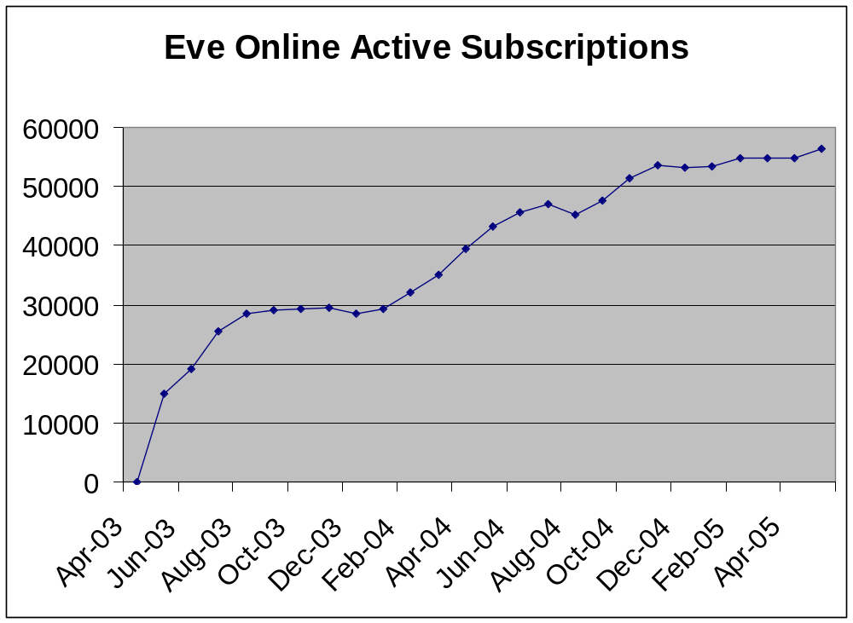

The Fringe, Better than Eve
We have the opportunity to learn from Eve’s strengths and weaknesses. MMOG games traditionally have a reputation for weak game play. They too often depend so much on the community aspects of the game that the game-play fun and action suffer. We decided to take the best of both worlds by producing a Sci-Fi game with a strong role-playing center, using the game engine from an action packed first-person shooter.

Eve’s greatest strength is its graphics and visual appeal. It also has an extremely string player community. It will be extremely important for us to maintain that level of graphical quality. Here are some of its weaknesses and why The Fringe will be better:

Weakness | Why We Are BETTER
Wasted precious development time on game aspects that are rarely used (character development) | Involve external testers early in the design and development process to get not only their opinions but to get real data on where they are spending time in the game.
Battle sequences are boring and no one wants to get in a battle for fear of losing precious resources they have acquired | Use a first-person shooter game engine. Promote battles by not making the cost of losing so big. Players can shoot and get killed over and over without losing their ship.
All of the ships look the same | We will provide a great deal of ownership by allowing the player to customize their ships to a great degree. Ships can be unique. This level of customization really keeps players hooked and returning, and develops a huge loyalty base.
So much time spent mining (hunting rabbits phenomenon) | We will provide players (even low level players) with MANY game vocations to get game money, not just mining. High level players will be encouraged financially to include other players in large ventures. Redundant tasks like mining can be performed by bots even when the player is off-line.
Eve prevents players (tries to) from selling their ships on e-bay because they are afraid of players cheating. | We will ENCOURAGE players to buy/sell/trade online assets, even with real world cash, by providing them with an auction center similar to e-bay, or at least facilitate the transfers. People MAY be able to buy higher levels, but it will not have an impact on other players as much.
Boring, Repetitive, or Tedious Music | Allow the player control over the songs they want to listen to and allow them to attach songs to events in future revisions of the game.

We have put a great deal of thought, experience, and passion into the design of The Fringe. While a complete description of its design are outside the scope of this document, you can always ask Rick or Justin for more (they will be happy to talk your ear off about it), or read the preliminary design specifications for the game if you are truly interested in investing with us.

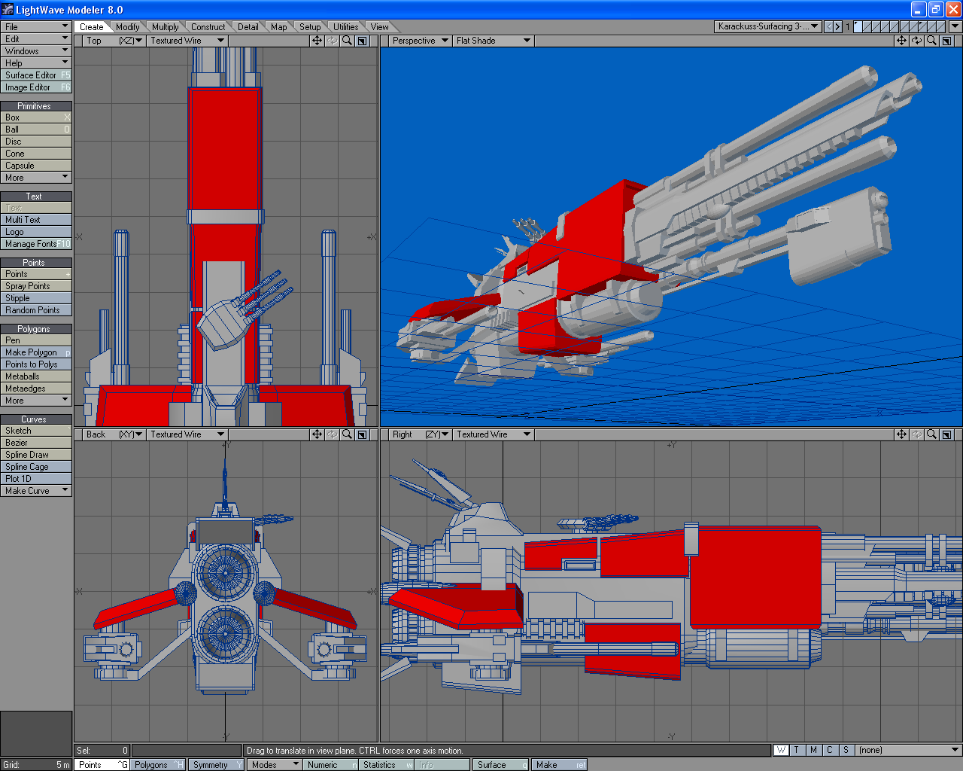

Marketing Plan

Revenue Streams
As you can see, the primary revenue stream will be subscriptions. In later versions of the game, we want to add some more revenue streams from the game. These may include, but are certainly not limited to:
- Getting a small percentage from trade transactions
- Merchandising (T-shirts, hats, toys, hoodies, mouse pads, etc.)
- Television and Movie Production and Rights
- Sale of the client and other tools to players
- In Game Advertising
- Shrink-Wrapped Client

Target Market
We have a clear picture of the target market:
- Young men, pre-teen to post college grad.
- Have a high-speed internet connection
- Have access to a credit card either of their own or their parents
- Have a good deal of technical savvy (can operate a computer well, are used to computer games and internet connections)

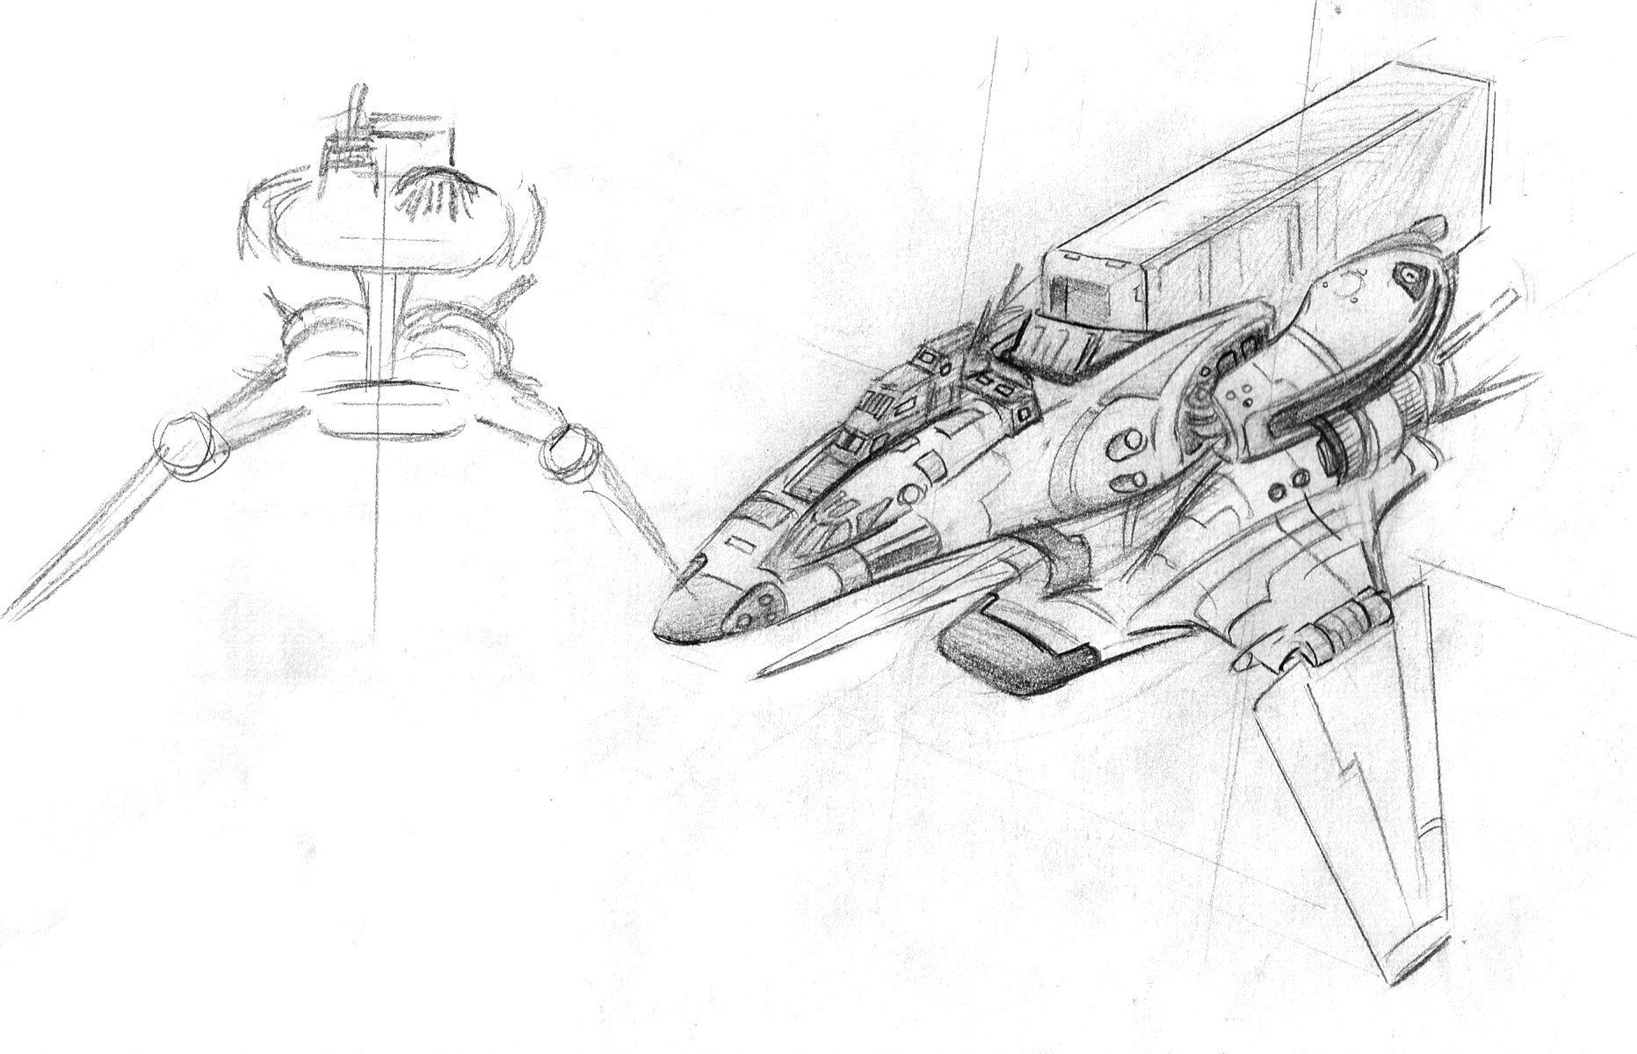

Advertising Campaign
Oddly enough, the greatest risk on launch day is NOT that we will have too few players. We are far more concerned with launching and not being able to provide for the massive hordes. Our goal is to have a rather limited launch so that we can thoroughly be prepared for the strain on the servers and the game, as well as the customer support. Our number one priority is to provide an EXCELLENT experience for our users, because we know that a small bit of bad word-of-mouth travels VERY quickly in the on-line world. We will grow the game is measured steps so that we can be prepared at every turn. This is also the reason we will shoot for an English only release, and then provide for other languages, starting with the Asian markets of Japan and China (along with an advertising campaign targeted for them) in their turn.

Tester Relations
Our very first line of attack involves the testers. We will make them feel special and appreciated, because they are extremely valuable to us. We will listen to their input and keep them involved in production. We will also reward them with gifts like T-shirts. Building this relationship is of critical importance because they will bring in their friends. As we reward them and they see improvement in the game and their own ideas being realized, they will be excited to have their friends play with them on launch day, because it will be a launch day for them as well!

Internet Based Marketing
The online gaming community is supported by an incredible network of gaming magazines and BLOGS. These magazines often have competitions and many other marketing opportunities. We will build a web-site that wets the appetites of game players all over the world.

Episodic Web-Cast Show
One thing about story lines in games is that everyone loves them, but no one wants to take the time to read them. We plan on producing an episodic show (at first web-cast, but you never know what might happen later) that tells the story, and stays up to date with what is really happening in the Fringe Universe. This episodic show will serve to be a marketing tool and possibly an additional revenue stream.

Traditional Marketing Tools
We will mete out the use of traditional marketing tools as we prepare ourselves for the huge in-flux of subscribers. The costs of producing much of these materials will be small because we already have great audio-visual content for the game. These tools are focused on our young male target market to include, but not be limited to:
- Our own Web-Site
- Gaming Magazines and Web Blogs
- Featured In-Game Events
- Sponsored Links from Other Sites
- Radio Ads
- Television Ads
- Movie Theater Ads
- Player Recruitment Incentives
- Promotions
- Merchandising (T-shirts, hats, toys, hoodies, mouse pads, etc.)
- Shrink-Wrapped Client Sales

